PRACTICAL ACTIVITY 6

VIRTUOUS FANNY

[virtuous.fanny@womentechsters.org](mailto:virtuous.fanny@womentechsters.org)

1. **Is your browser running HTTP version 1.0 or 1.1? What version of HTTP is the server running?**

It is running HTTP 1.1

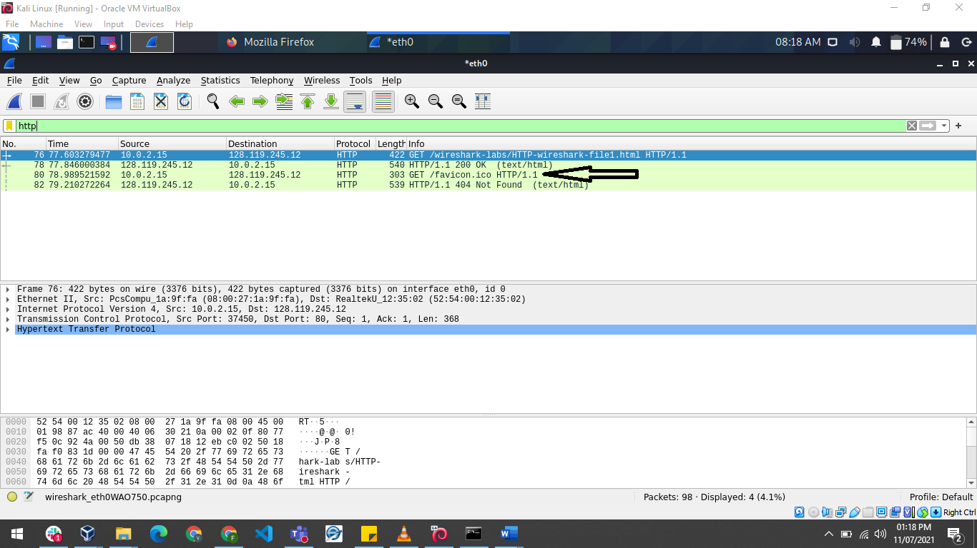

1. **What languages (if any) does your browser indicate that it can accept to the server? In the captured session, what other information (if any) does the browser provide the server with regarding the user/browser?**

Its accepted language is US English

It accepts Hyper Text Markup Language, HTML,

It also accepts xhtml+xml application

Its host is “gaia.cs.umass.edu\r\n

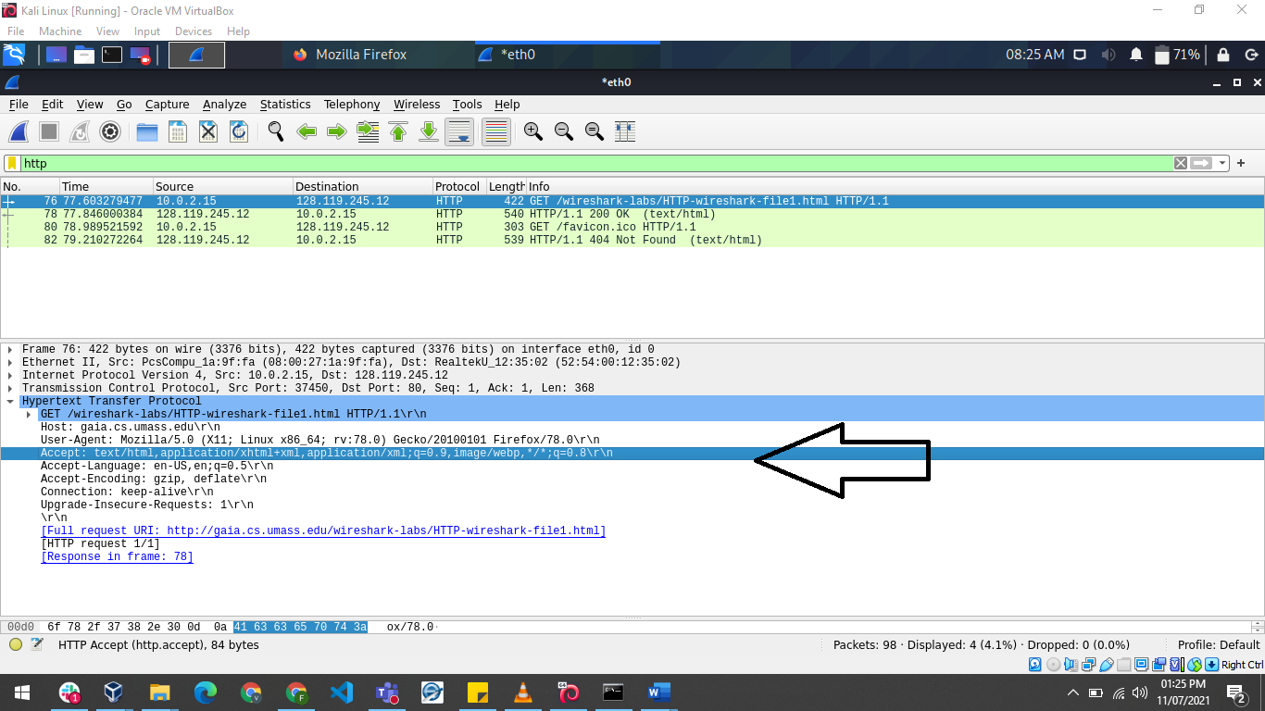

1. **What is the IP address of your computer? Of the gaia.cs.umass.edu server?**

128.119.245.12

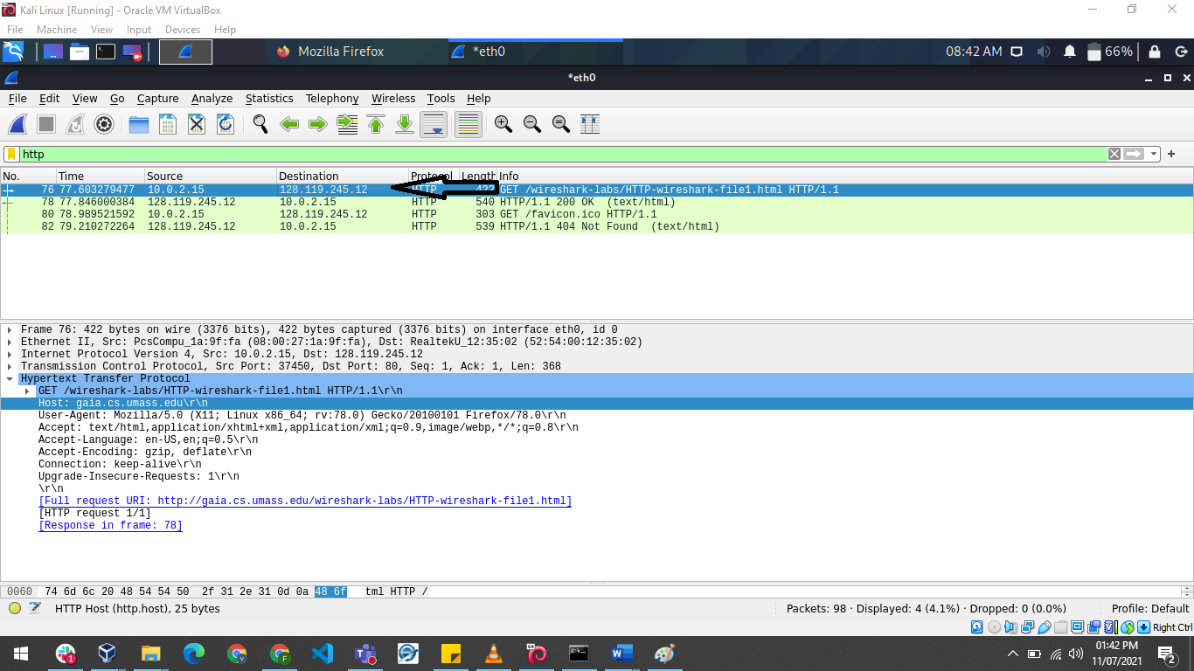

1. **What is the status code returned from the server to your browser?**

200 OK

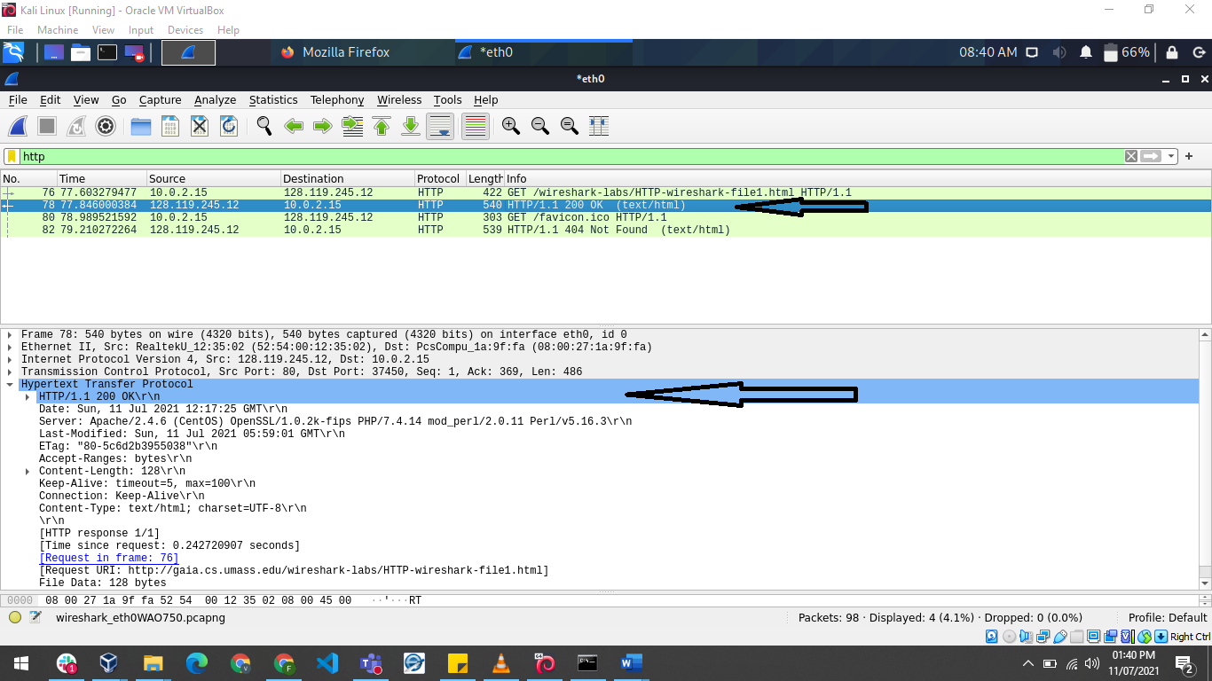

1. **When was the HTML file that you are retrieving last modified at the server?**

It was last modified Sunday 11th July 2021 05:59:01 GMT\r\n (see blue highlights)

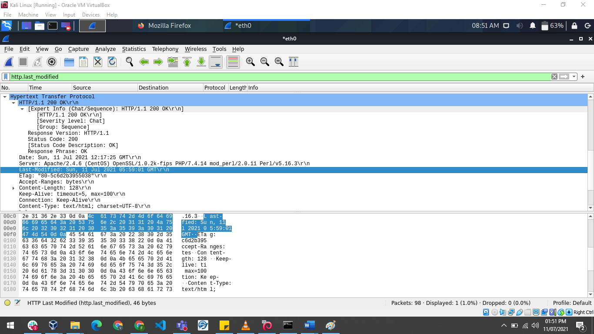

1. **How many bytes of content are being returned to your browser?**

128 bytes

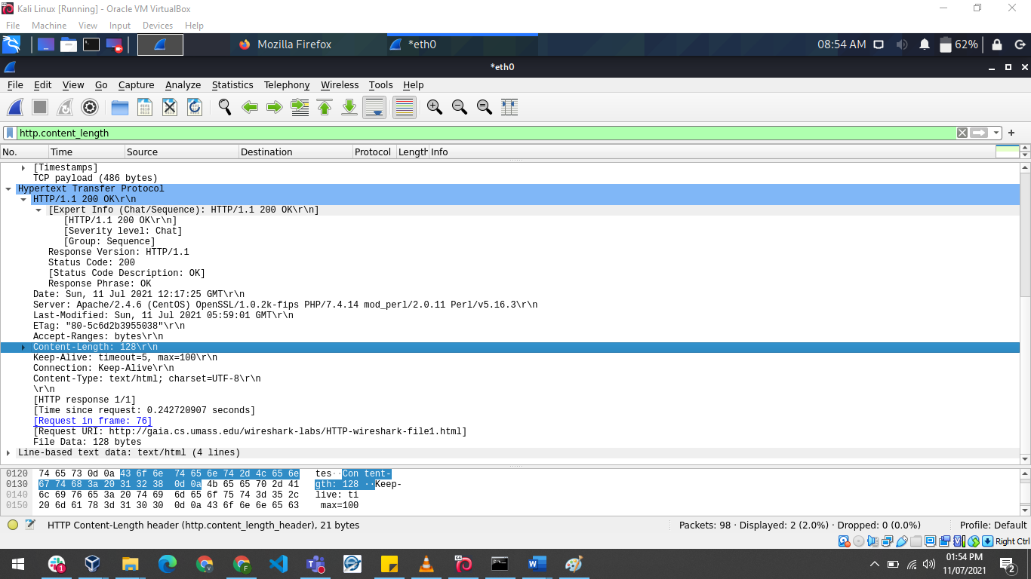

1. **By inspecting the raw data in the packet content pane, do you see any http headers within the data that are not displayed in the packet-listing window? If so, name one**.

The raw data in the packet content pane is the same with what is shown in the packet-listing window

**Task A: For questions 1-7, first write a brief but precise answer for each of the above questions, then write a (combined) paragraph explaining and discussing your observations from the above practice questions. Note that your answer may benefit from explaining and/or referring to some of your observations explicitly.**

The packet capture is of a single file html file website.

the http version is version 1.1 and this implies that HTTP 1.1 being the latest version of Hypertext Transfer Protocol (HTTP), the World Wide Web application protocol that runs on top of the Internet's TCP/IP suite of protocols. HTTP 1.1 provides faster delivery of Web pages than the original HTTP and reduces Web traffic.

It accepts US English, its IP address is 128.119.245.12 as this is the destination of the website being tracked.

the status code is 200 OK and this means the response to a my request made to the server.

The last time the file was modified was Sunday 11th July 2021 05:59:01

The bytes of content returned to the browser is 128 bytes

The raw data in the packet content pane is the same with what is shown in the packet-listing window